MINI PROJECT – Electronic waste Recyclability

Cohort – 12
Sl.No | Member Name | Assigned Role
1 | Dhanyashree K | Data Collection
2 | Shreelatha G | Fine tuning
3 | Peeyush Suryan | Data Cleaning and Feature Engineering
4 | Gurugula Surya Chenna Siva Sankar Reddy | Data Collection
5 | Rajendra Gowda M | Data Cleaning and Feature Engineering
6 | Rohan M E | Data Collection
7 | Sukhi R | Model Training
8 | Sowjanya B M | Documentation
9 | Gagan H R | Model Training
10 | Bharath M | Data Cleaning and Feature Engineering
11 | Saniya Kausar T | Fine tuning
12 | Tasbeeha F | Model Training
13 | Madan b d | Data Cleaning and Feature Engineering
14 | Nandish R | Documentation
15 | Imrankhan Ghori | Not Active

DAY 1 – Problem Statement Allocation and Initial Research
Date: 6th March 2026
Present Members: Dhanyashree k, Shreelatha G, Peeyush Suryan, Surya Reddy, Sukhi R, Saniya Kausar T, Rajendra gowda M, Sowjanya B M, Madan b d, Bharath M, Rohan, Gagan, nandish
Absent Members: Imrankhan Ghori
Work Done:
- The mini-project problem statement was officially assigned to the team on this day.
- Due to limited time, a formal team meeting could not be conducted.
- All team members independently began researching the assigned problem statement to understand:
The project objective
- Expected outputs
- Possible datasets
- Suitable machine learning approaches
- Initial exploration and background study were initiated to prepare for structured planning from the next day onward.
Note : The members listed under Present Members are those who attended the daily meeting on this date.

DAY 2 – Role Allocation and Environmental Data Acquisition
Date: 9th March 2026
Present Members: Dhanyashree k, Shreelatha G, Peeyush Suryan, Surya Reddy, Sukhi R, Saniya Kausar T, Rajendra gowda M, Madan b d, Bharath M, Rohan, Gagan, Sowjanya
Absent Members: Imrankhan Ghori,Nandish
Work Done:
1. Project Structuring and Role Allocation
- A one-hour team meeting was conducted to formally initiate the project. Roles were distributed under the following categories:
- Documentation
- Data Collection
- Data Cleaning and Feature Engineering
- Model Training and Testing
The project scope was aligned with SDG 14 – Life Below Water, focusing on estimating ocean plastic leakage using environmental indicators.
The President created a new git hub repository and members instructed to push their respective contributions.
Link: https://github.com/DhanyaSvit/E-waste-Recyclability
2. Dataset Collection from Authentic Sources
- The Data Collection team explored and gathered datasets from reliable global sources, including:
Kaggle
Our World in Data
NASA SEDAC
World Bank Open Data
Environmental research portals
- Datasets were shortlisted based on their alignment with the problem statement.
The collected dataset included the following key features:
- Item
- Category
- Gold
- Silver
- Platinum
- Rhodium
- Nickel
- Tin
- Lithium
- Aluminum
- Carbon
- Profit
3. Technical Relevance Assessment
The team analyzed whether the collected features in the E-waste dataset support the objective of estimating the profit from recyclable electronic waste materials.
- Item: Represents the type of electronic product such as phones, appliances, or speakers that generate e-waste.
- Category: Classifies the electronic item into different product groups for better analysis.
- Gold: Indicates the quantity of gold present in the electronic component, which contributes to recycling value.
- Silver: Represents the amount of silver that can be recovered from the device.
- Platinum: Shows the presence of platinum, a valuable rare metal used in electronic circuits.
- Rhodium: Represents another rare and high-value metal found in electronic components.
- Nickel: Indicates the amount of nickel available in the device materials.
- Tin: Represents tin content used in soldering and electronic connections.
- Lithium: Shows the lithium amount commonly found in batteries and energy storage components.
- Aluminum: Indicates recyclable aluminum content present in electronic structures.
- Carbon: Represents carbon-based material contribution within the device composition.
- Profit ($): This is the target variable representing the estimated profit that can be obtained from recycling the electronic item.
Initial validation included:
- Checking feature completeness
- Verifying units of measurement
- Assessing consistency across years/regions
- Confirming suitability for regression modelling
4. Documentation
The documentation team recorded the following:
- Meeting details
- Dataset sources explored
- Feature relevance discussion
- Initial technical validation process
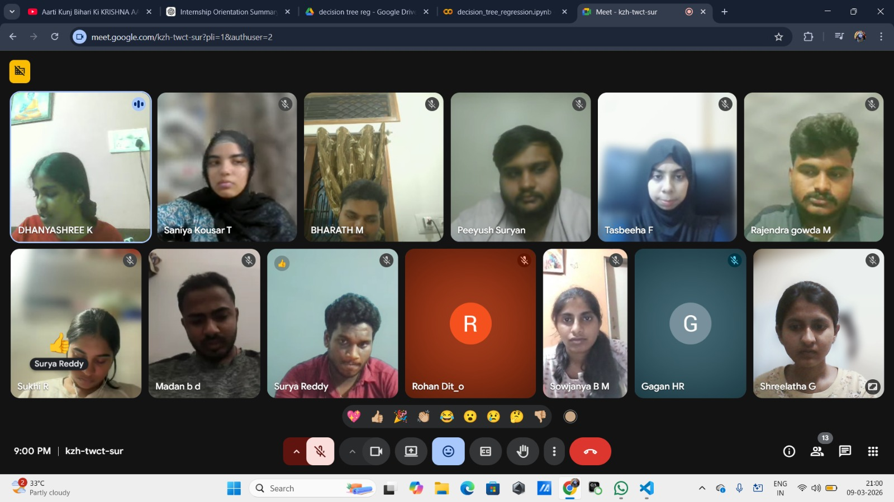

DAY 3 – Data Cleaning, Feature Engineering and Preprocessing
Date: 10th March 2026
Present Members: Dhanyashree k, Shreelatha G, Peeyush Suryan, Surya Reddy, Sukhi R, Saniya Kausar T, Rajendra gowda M, Madan b d, Bharath M, Rohan, Gagan, Tasbeeha
Absent Members: Imrankhan Ghori, Nandish
Work Done:
1. Workflow Discussion
- A team meeting (approximately 1 hour) was conducted to discuss the data preprocessing workflow, modeling readiness, and feature preparation strategy.
- All teams continued working on their respective responsibilities.
2. Data Cleaning and Preprocessing Activities
- The Data Cleaning Team conducted a focused working session to preprocess the dataset and prepare it for modeling.
The following technical steps were performed:
- Checked for missing values and handled inconsistencies
- Verified and standardized units of measurement across features
- Checked for duplicate entries
- Validated numerical formatting
3. Statistical Analysis and Transformations
- To ensure suitability for regression modeling:
- Skewness of numerical features was calculated to analyze data distribution.
- Log transformations were explored for highly skewed variables to improve normality and model performance (final usage to depend on model evaluation).
- Distribution patterns were analyzed to decide appropriate preprocessing techniques.
4. Feature Engineering
Feature engineering was performed to improve the quality and usefulness of the dataset for machine learning modeling.
- Data Cleaning: Missing values and inconsistent entries in the dataset were checked and handled to ensure data quality.
- Feature Selection: Important features such as Gold, Silver, Platinum, Rhodium, Nickel, Tin, Lithium, Aluminum, and Carbon were selected because they directly influence the recycling profit.
- Categorical Encoding: The Item and Category columns were converted into numerical form using encoding techniques so that machine learning algorithms could process them.
- Feature Scaling: Numerical features representing metal quantities were normalized or scaled to maintain consistent ranges and improve model performance.
- Derived Feature Analysis: The relationship between metal composition and Profit ($) was analyzed to identify the most influential materials contributing to recycling value.
- Outlier Detection: Extremely high or low values in metal quantities were examined to ensure they do not negatively impact the prediction model.
5. Repository Update
- The preprocessed dataset and preprocessing code were pushed to the GitHub repository.

The documentation team recorded the following:
- Cleaning steps performed
- Feature engineering details
- Statistical analysis conducted
- Repository updates
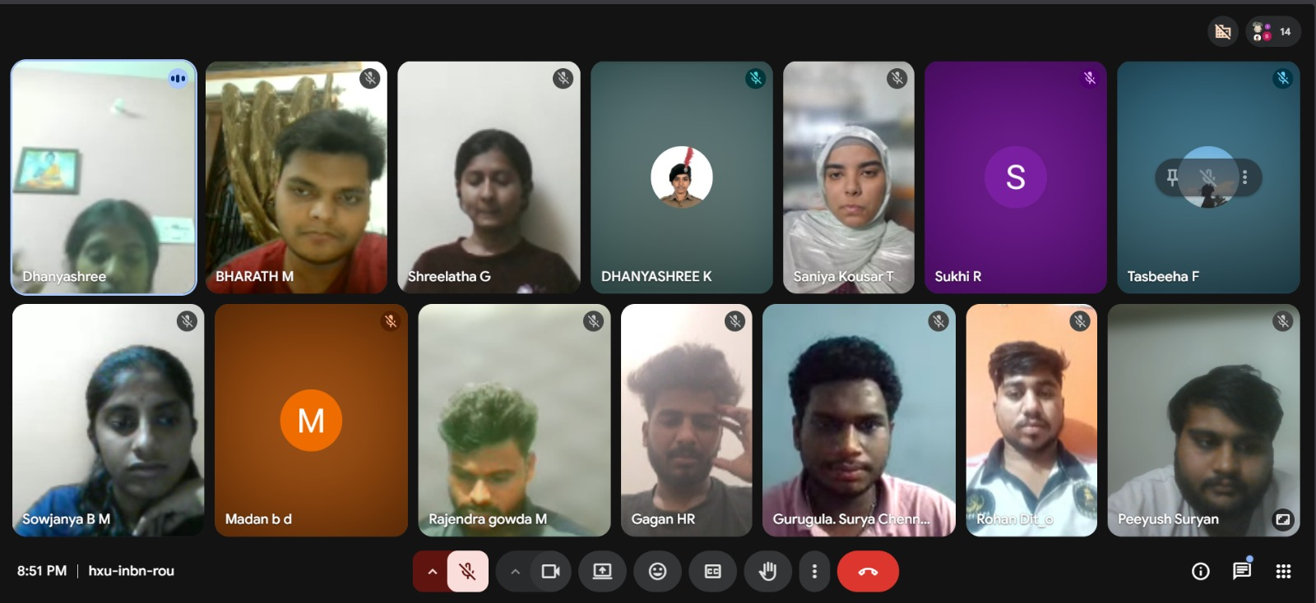

DAY 4 – Model Training, Fine tuning and Comparative Analysis
Date: 11th March 2026
Present Members: Dhanyashree k, Shreelatha G, Peeyush Suryan, Surya Reddy, Saniya Kausar T, Rajendra gowda M, Madan B D, Bharath M, Sowjanya B M, Sukhi R, Rohan
Absent Members: Nandish R, Imrankhan Ghori, Gagan, Tasbeeha F
Work Done:
1. Team Meeting
A one-hour team meeting was conducted to discuss the following:
- Model selection strategy
- Baseline model implementation
- Comparison of different regression approaches
- Evaluation methodology
2. Model Training and Implementation
The Model Training Team implemented and experimented with multiple regression models to estimate ocean plastic leakage.
- Linear Regression (Baseline Model)
- Polynomial Regression (to capture non-linear relationships)
- Decision Tree Regressor
- Random Forest Regressor
- Each model was trained using the preprocessed dataset.
3. Comparative Model Analysis
- Model performance was evaluated using appropriate regression metrics such as:
- MAE
- MSE
- RMSE
- R2 Score
- Performance differences were analyzed to understand:
- Linear vs. non-linear behavior
- Overfitting risks (especially in Polynomial and Tree-based models)
- Generalization capability
4. Repository Update
- Model implementation scripts were pushed to the GitHub repository.

The documentation team recorded the following:
- Models implemented
- Evaluation metrics obtained
- Observations from comparative analysis
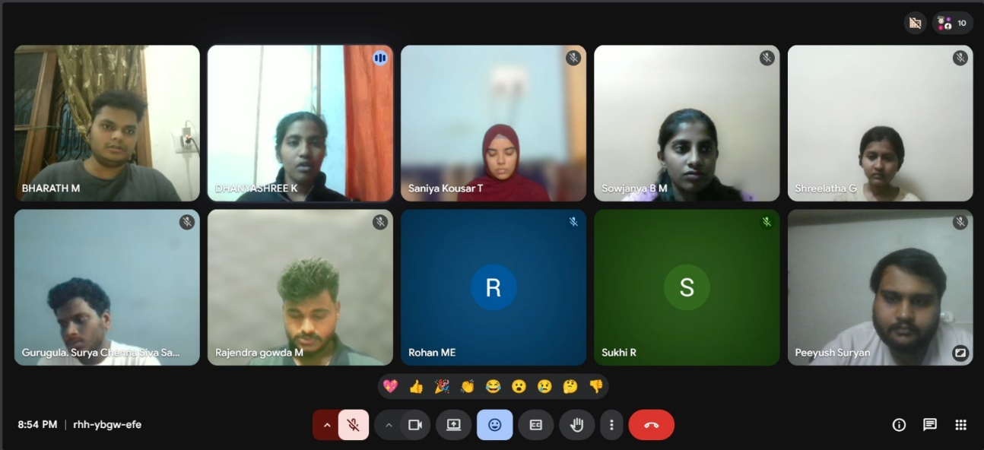

DAY 5 – Model Finalization and Performance Review
Date: 12th March 2026
Present Members: Dhanyashree K, Shreelatha G, Peeyush Suryan, Surya reddy, Saniya Kausar T, Bharath M, Sowjanya B M , Rajendra Gowda M, Madan B D, Tasbeeha, Sukhi R,
Absent Members: Gagan, Rohan, Nandish R, Imrankhan Ghori
Work Done:
1. Project Review Meeting
A team meeting was conducted to review and compare the performance of all implemented machine learning models on the Electronic Waste Recoverability dataset.
The models evaluated during experimentation were:
- Linear Regression
- Polynomial Regression
- Decision Tree Regressor
- Random Forest Regressor
Each model’s performance was analyzed based on:
- Evaluation metrics (R² Score, Mean Squared Error)
- Model generalization capability
- Stability between training and testing datasets
- Ability to capture complex relationships between metal composition and recoverable value
2. Evaluation and Model Selection Discussion
During the initial experimentation phase, only a limited set of variables were used for model training. These variables included:
- Gold
- Silver
- Platinum
Using Linear Regression with these limited features produced the following observations:
- Train R²: High training accuracy
- Test R²: Moderate testing accuracy
This gap between training and testing performance indicated:
- Poor generalization
- Limited ability to capture non-linear relationships
- Feature insufficiency for accurate prediction
After discussion, the team decided to include all relevant features from the dataset for better model learning.
The final feature set included:
- Gold
- Silver
- Platinum
- Rhodium
- Nickel
- Tin
- Lithium
- Aluminum
- Carbon
- Profit ($)
- Total Value
These features were used as independent variables (X), and Recoverable was used as the dependent variable (y).
To maintain feature scaling consistency, StandardScaler was applied before model training.
3. Final Model Selection and Performance Evaluation
- After conducting comparative analysis across all models, the team finalized the Random Forest Regression as the final model due to its:
- Better ability to capture complex and non-linear relationships
- Reduced overfitting compared to Decision Tree models
- Higher prediction accuracy
- Strong stability across training and testing datasets
- Random Forest combines multiple decision trees and aggregates their predictions, which improves overall model robustness and prediction reliability for the electronic waste recoverability prediction problem.

Final Evaluation Metrics (Random Forest Regressor)
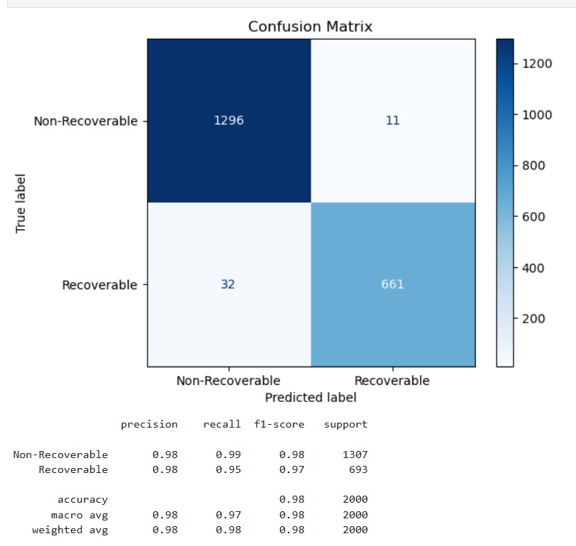
Test Performance:
- Tuned Model Accuracy: 0.9790(=97.9%)
Classification metrics
Non-recoverable waste
- Precision:0.98
- Recall:0.99
- F1-Score:0.98
- Support:1307 samples
Recoverable Waste
- Precision:0.99
- Recall:0.95
- F1-Score:0.97
- Support:693 samples

Observation:

• The model demonstrates very high precision and recall values for both categories.
• The F1-scores close to 1.0 indicate balanced classification performance.
• The accuracy of 97.9% confirms strong predictive ability.

Model Performance Visualization
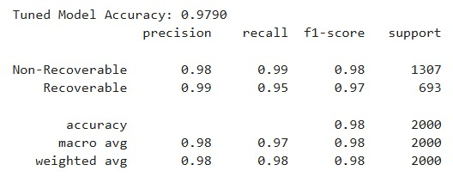
Conclusion:
• The tuned machine learning model achieves high classification accuracy and reliable prediction results.
• The performance metrics indicate minimal misclassification and strong generalization capability.
• Therefore, the model is suitable for automatic classification of electronic waste recyclability.
4. Documentation and Submission
Since this was the final day before submission:
- Documentation was finalized and structured
- Implementation details were consolidated
- Model comparison observations were recorded
- Evaluation metrics were updated
- Performance graphs were included
- GitHub repository was verified and finalized
Final Outcome of Day 5
- Final model selected: Random Forest Regressor
- Evaluation metrics computed and validated
- Overfitting analysis completed
- Performance visualization added
- Documentation finalized
- Project prepared for submission
Sl.No | Member Name | Role | Rating (0–5) | Remarks
1 | Dhanyashree K | Data Collection | 4.8 | Led team coordination and drove dataset preparation by deriving the Total Value feature from metal composition and scrap prices.
2 | Shreelatha G | Fine Tuning | 4.5 | Actively contributed through dataset research, model fine-tuning, and supporting project documentation.
3 | Peeyush Suryan | Data Cleaning and feature Engineering | 4.6 | Supported dataset research, actively worked on data cleaning, and maintained team attendance documentation.
4 | Gurugula Surya Chenna Siva Sankar Reddy | Data Collection | 4.5 | Actively contributed to dataset collection and participated in team meetings and review discussions.
5 | Rajendra Gowda M | Data Cleaning and feature Engineering | 5 | Showed active participation and worked efficiently as part of the data cleaning team.
6 | Rohan M E | Data Collection | 3.5 | Contributed to dataset collection and participated in team meetings and discussions.
7 | Sukhi R | Modelling Training | 4.8 | Actively participated in the project and worked effectively on model training using Decision Tree.
8 | Sowjanya B M | Documentation | 4.5 | Maintained complete and timely documentation throughout the project in a professional and organized manner.
9 | Gagan H R | Modelling Training | 3 | Participated in some team discussions but had limited contribution to the project due to personal circumstances.
10 | Bharath M | Data Cleaning and feature Engineering | 5 | Demonstrated strong team engagement and contributed to preparing the dataset through cleaning tasks.
11 | Saniya Kousar T | Fine Tuning | 5 | Contributed through active collaboration and supported the fine-tuning and evaluation of the model.
12 | Tasbeeha F | Modelling Training | 5 | Actively participated in the project and worked on training the Random Forest model, which was later finalized by the team.
13 | Madan b d | Data Cleaning and feature Engineering | 3.25 | Despite limited network access, he collaborated with another team member to contribute to the project.
14 | Nandish R | Documentation | 3 | Was part of the documentation team and attended meetings, though active contribution was limited.
15 | Imrankhan Ghori | Not active | -------- | ------------------------------------------------------------
